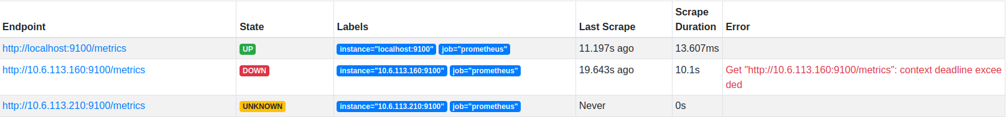

multiple_target: <https://stackoverflow.com/questions/53295711/multiple-targets-on-prometheus>

installation prometheus & grafana:

https://antonputra.com/monitoring/install-prometheus-and-grafana-on-ubuntu/#install-node-exporter-on-ubuntu-2004